 |  | INTERNATIONAL TELECOMMUNICATION UNION
 |  | ITU-T | G.984.3
 |  | TELECOMMUNICATION  STANDARDIZATION SECTOR  OF ITU |  | Amendment 3  (12/2006)
SERIES G: TRANSMISSION SYSTEMS AND MEDIA, DIGITAL SYSTEMS AND NETWORKS
Digital sections and digital line system – Optical line systems for local and access networks

Gigabit-capable Passive Optical Networks (G-PON): Transmission convergence layer specification
Amendment 3:

CAUTION !
PREPUBLISHED RECOMMENDATION
This prepublication is an unedited version of a recently approved Recommendation. It will be replaced by the published version after editing. Therefore, there will be differences between this prepublication and the published version.

FOREWORD
The International Telecommunication Union (ITU) is the United Nations specialized agency in the field of telecommunications. The ITU Telecommunication Standardization Sector (ITU-T) is a permanent organ of ITU. ITU-T is responsible for studying technical, operating and tariff questions and issuing Recommendations on them with a view to standardizing telecommunications on a worldwide basis.
The World Telecommunication Standardization Assembly (WTSA), which meets every four years, establishes the topics for study by the ITU-T study groups which, in turn, produce Recommendations on these topics.
The approval of ITU-T Recommendations is covered by the procedure laid down in WTSA Resolution 1.
In some areas of information technology which fall within ITU-T's purview, the necessary standards are prepared on a collaborative basis with ISO and IEC.

NOTE
In this Recommendation, the expression "Administration" is used for conciseness to indicate both a telecommunication administration and a recognized operating agency.
Compliance with this Recommendation is voluntary. However, the Recommendation may contain certain mandatory provisions (to ensure e.g. interoperability or applicability) and compliance with the Recommendation is achieved when all of these mandatory provisions are met. The words "shall" or some other obligatory language such as "must" and the negative equivalents are used to express requirements. The use of such words does not suggest that compliance with the Recommendation is required of any party.

INTELLECTUAL PROPERTY RIGHTS
ITU draws attention to the possibility that the practice or implementation of this Recommendation may involve the use of a claimed Intellectual Property Right. ITU takes no position concerning the evidence, validity or applicability of claimed Intellectual Property Rights, whether asserted by ITU members or others outside of the Recommendation development process.
As of the date of approval of this Recommendation, ITU [had/had not] received notice of intellectual property, protected by patents, which may be required to implement this Recommendation. However, implementers are cautioned that this may not represent the latest information and are therefore strongly urged to consult the TSB patent database at http://www.itu.int/ITU-T/ipr/.

© ITU 2006
All rights reserved. No part of this publication may be reproduced, by any means whatsoever, without the prior written permission of ITU.
Amendment 3 to Recommendation G.984.3
Gigabit-capable Passive Optical Networks (G-PON): Transmission convergence layer specification

Summary
This amendment includes various clarifications and enhancements to G.984.3.

Introduction
The G-PON GTC layer specification, G.984.3, requires several small modifications to make certain points clearer, and to add some new functionality, including the carriage of SDH TUs over GEM. This amendment provides the language to implement these changes and additions.

Modifications to existing sections of G.984.3

Modify section 9.2.3.1 Upstream_Overhead message
In the description of octet 10, append the text “Note 4”.
Add the following note at the end of the section.
“NOTE 4 – Be mindful that the coding of the power level modes in the upstream overhead message, where 0 is highest and 2 is lowest, is opposite to that in the serial_number_ONU message.”

Modify section 9.2.4.1 Serial_number_ONU message
In the description of octet 12, append the text “Note 2”.
Add the following note at the end of the section.
“NOTE 2 – Be mindful that the coding of the power level modes in the serial_number_ONU message, where 2 is highest and 0 is lowest, is opposite to that in the upstream overhead message.”

Modify section 9.2.4.5
Modify the note at the end of the section to read as follows.
“NOTE – The first fragment of the key (bytes 0-7) will have Frag_Index = 0, the second (bytes 8-15) will have Frag_Index = 1, and so on, for as many fragments are required to carry the key. Currently, only two fragments are required for AES-128.”

Modify section 9.2.3.8 Encrypted_VPI/Port-ID message
Add a note to the end of the section
“NOTE – This message is not required to complete ranging, or to make any connection active. It can be issued at any time in the life of a connection. Changing the encryption mode of an active connection will likely cause temporary service interruption.”

Modify section 11.1.1 Items detected at OLT
In the SFi row, in the cancellation conditions column, replace “< 10^{−y+1}” with “< 10^{−(y+1)}”
In the SDi row, in the cancellation conditions column, replace “< 10^{−x+1}” with “< 10^{−(x+1)}”
Add the following two rows to the table
TIWi | Timeslots Interference Warning | In any sequential N frames, an ONT transmission is received at any unexpected place | Generate Loss_of_phy_layer_I notification | In any sequential N frames, an ONT transmission is received at expected place
TIA | Timeslots Interference Alarm | An ONT turns on its laser in any unassigned timeslots for it | Generate Loss_of_phy_layer_I notification | The faulty ONU is corrected or eliminated

Modify Appendix I Transport of user traffic over GEM channels
Change the introductory paragraph to this appendix so that it reads as follows.
“This appendix will contain informative material concerning the transport of common user protocols using the GEM channel in G-PON.
It should be noted that there are several implementation options for the carriage of TDM services over GEM. The raw TDM data can be sent over GEM directly (section I.2); or the TDM can be packaged into Ethernet, which is then sent over GEM (section I.3); or the TDM can be packaged into SDH tributary units, which is then sent over GEM (section I.4). The choice of option should be directed by the system architecture. For example, if the service stream is destined to be switched/routed across the wide area network, then Ethernet encapsulation is preferable. Alternatively, if the service stream will be terminated locally at the OLT equipment, then SDH encapsulation is preferable.”

Addition of new sections to G.984.3

Add section I.4 to Appendix I
I.4. SDH over GEM
ITU recommendation G.707 defines Tributary Unit (TU) structures. These structures contain user data as well as several mechanisms to preserve and recover data timing that is independent from the transport system timing. GEM can provide the same type of synchronous transport as SDH can, so it is possible to carry TU structures over GEM. This section lays out the details of this method.

I.4.1 Review of SDH TU structures.
In SDH transmission structures, a TU includes a low level VC and a TU PTR. There are 4 types of TUs: TU-11, TU-12, TU-2, and TU-3. A TU-11 is used to carry DS1 service. A TU-12 is used to carry E1 service. A TU-2 is used to carry a DS2 service, and a TU-3 is used to carry a DS3 or E3 service.

The TU-x structures are illustrated in figures I-4 to I-6. Note that the bytes shown in the diagram are ordered starting at the upper left, going left to right, then on to the next line, and so forth.

[Note for TSB staff: the following 3 figures are copied from G.707. Please reuse those as the source for these drawings, as they will be better formatted.]
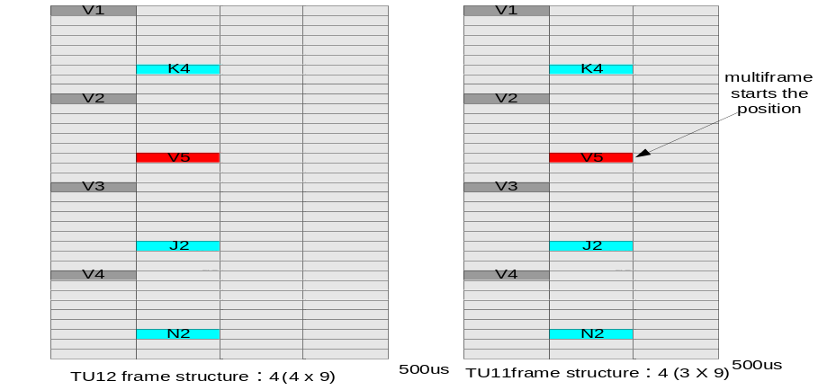

Figure I-4 The TU-12 and TU-11 Frame Structures

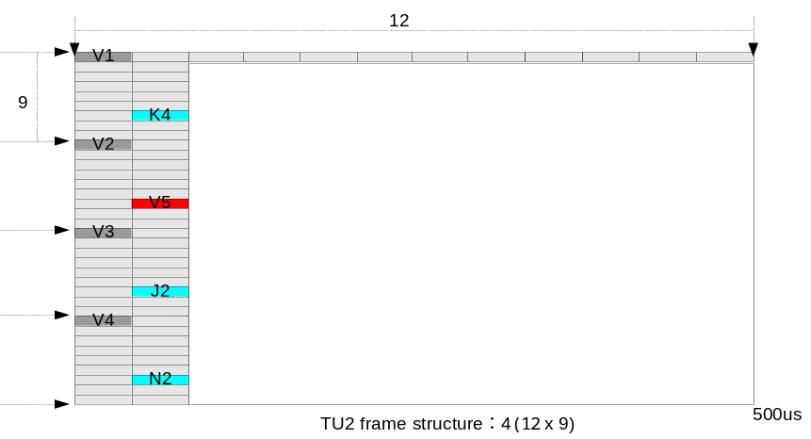

Figure I-5 The TU-2 Frame Structure

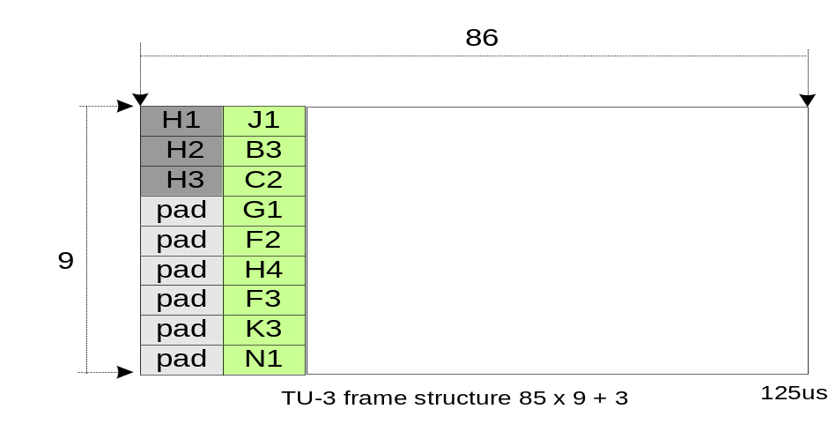

Figure I-6: The TU-3 frame structure

The structure and function of the pointers in the V1, V2, and V3 bytes in the TU-11, TU-12, and TU2; and in the H1, H2 and H3 bytes in a TU-3 frame, continue to operate exactly as described in G.707.
I.4.2 Transport of TU structures over GEM.
The structure about a TU frame mapped into a GEM frame is shown below:
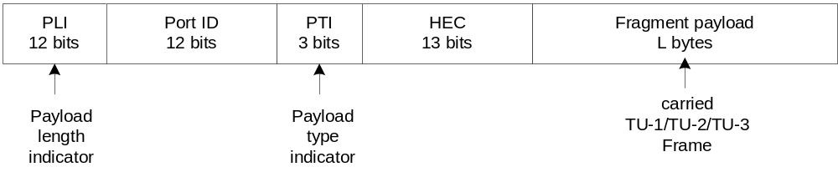
Figure 4 GEM frame structure with TU frame data payload
Each TU connection is assigned its own GEM Port-ID. Each TU frame always has a fixed size. This size depends on the type of TU being carried. In addition, the GEM process receives a TU frame exactly once every transmission cycle. This cycle period is measured in the time-base of the G-PON system, which is a synchronous transport system with traceable timing. Hence, clock integrity can be maintained. It should be noted that GEM fragmentation is permitted; however, some implementations may attempt to coordinate the G-PON framing and SDH framing processes such that fragmentation is avoided.
The length and transmission period of TU-1/TU-2/TU-3 capsulated in a GEM frame are shown below:
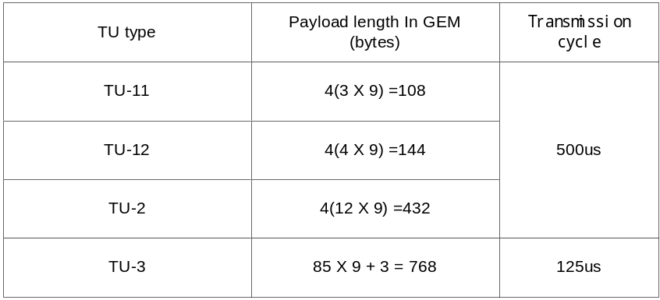
The payloads are assembled using the structures as shown in Figs. 1-3. Note that in the case of the TU-3, the 6 fixed stuff bytes (marked ‘pad’ in Fig. 3) are not transported, because they carry no useful information.
The receiver side can identify the type of the carried TUs in two way. Primarily, the Port-ID used would have a provisioned association with the TU that it is carrying. Secondarily, the length of the payload would give an additional check on the TU type, since the payload lengths are fixed for each TU type.
Note that while the GEM frame generation process is locked to the G-PON frame timing, there can still be delays in the frame transmission caused by low-level PON processes (e.g, ranging). For typical ranging procedures, two frames at a time are used for ranging. Therefore, the receiving process at the OLT must queue up sufficient TU data so that the client SDH processor can be served with its TU payloads synchronously.
____________

